**Lab 5**

Lists , tuples , sets , dictionaries

1.The following is a list of 10 students ages:

ages = [19, 22, 19, 24, 20, 25, 26, 24, 25, 24]

I. Sort the list and find the min and max age

II. Add the min age and the max age again to the list

III. Find the median age (one middle item or two middle items divided by two)

IV. Find the average age (sum of all items divided by their number )

V. Find the range of the ages (max minus min)

VI. Compare the value of (min - average) and (max - average), use _abs()_ method

Code:

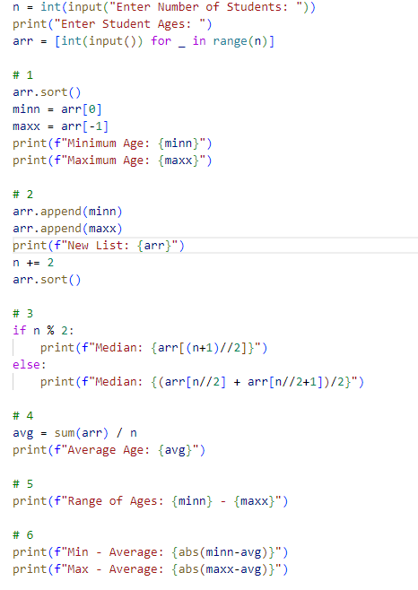

Output:

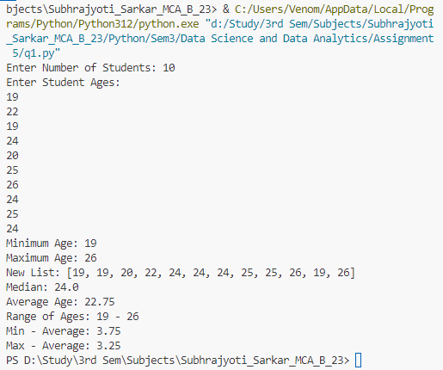

2.Iterate through the list, ['Python', 'Numpy','Pandas','Django', 'Flask'] using a for loop and print out

the items.

Code:

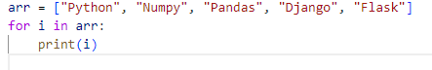

Output:

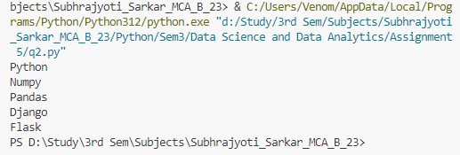

3.Create fruits, vegetables and animal products tuples.

I. Join the three tuples and assign it to a variable called food_stuff_tp.

II. Change the about food_stuff_tp tuple to a food_stuff_lt list

III. Slice out the middle item or items from the food_stuff_tp tuple or food_stuff_lt list.

IV. Slice out the first three items and the last three items from food_staff_lt list

V. Delete the food_staff_tp tuple completely

Code:

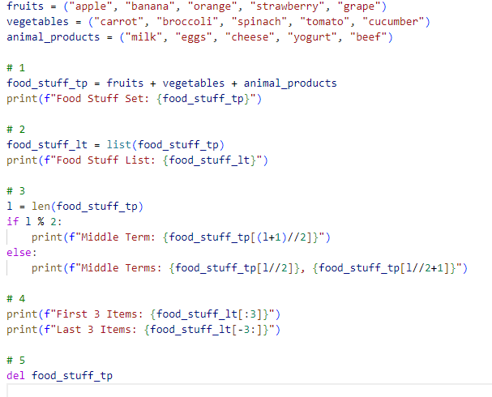

Output:

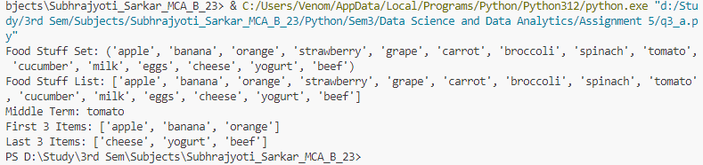

3. Create a set given below

it_companies = {'Facebook', 'Google', 'Microsoft', 'Apple', 'IBM', 'Oracle', 'Amazon'}

A = {19, 22, 24, 20, 25, 26}

B = {19, 22, 20, 25, 26, 24, 28, 27}

age = [22, 19, 24, 25, 26, 24, 25, 24]

I. Find the length of the set it_companies

II. Add 'Twitter' to it_companies

III. Insert multiple IT companies at once to the set it_companies

IV. Remove one of the companies from the set it_companies

V. What is the difference between remove and discard

Code:

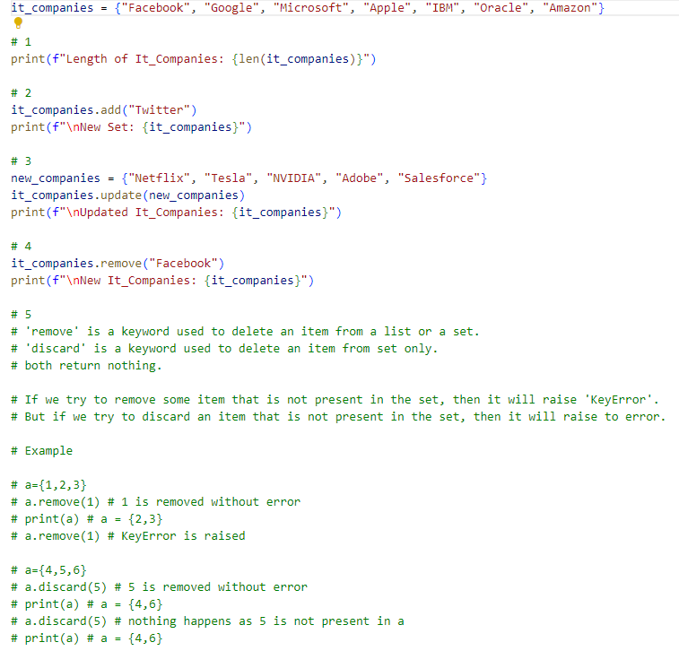

Output:

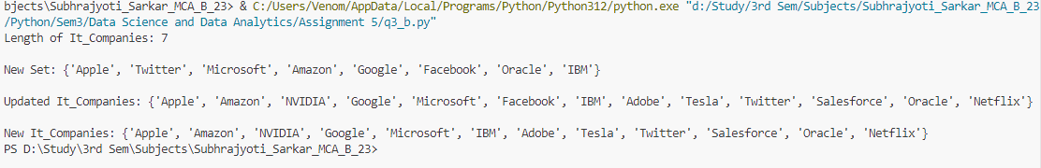

4. From the above sets A and B

I. Join A and B

II. Find A intersection B

III. Is A subset of B

IV. Are A and B disjoint sets

V. Join A with B and B with A

VI. What is the symmetric difference between A and B

VII. Delete the sets completely

Code:

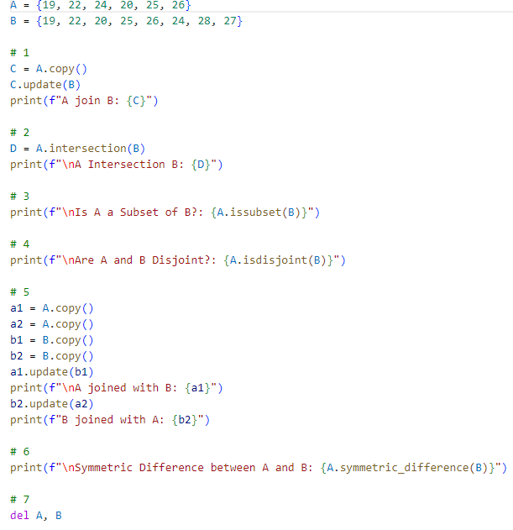

Output:

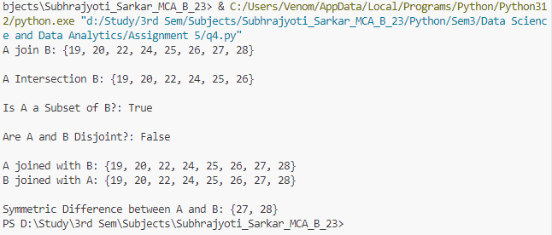

5. Create an empty dictionary called dog.Add name, color, breed, legs, age to the dog dictionary

Code:

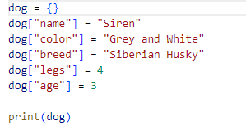

Output:

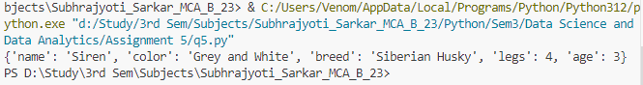

6. Create a student dictionary and add first_name, last_name, gender, age, marital status, skills,

country, city and address as keys for the dictionary

I. Get the length of the student dictionary

II. Get the value of skills and check the data type, it should be a list

III. Modify the skills values by adding one or two skills

IV. Get the dictionary keys as a list

V. Get the dictionary values as a list

VI. Change the dictionary to a list of tuples using _items()_ method

VII. Delete one of the items in the dictionary

VIII.Delete one of the dictionaries

Code:

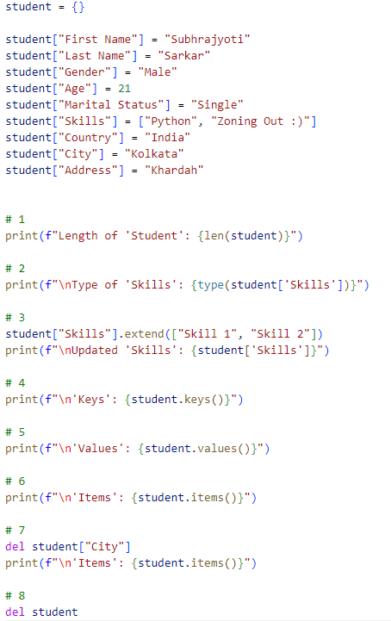

Output:

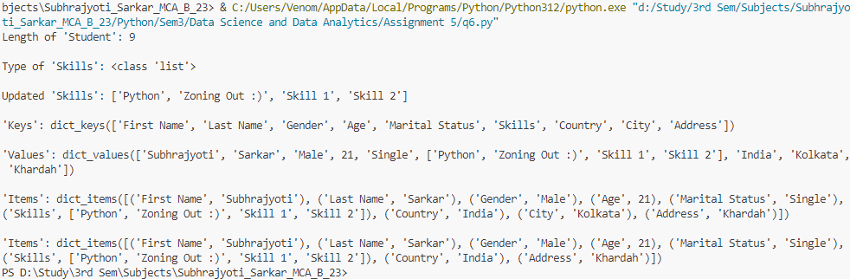

7. Create a person dictionary.

person={

'first_name': 'Asabeneh',

'last_name': 'Yetayeh',

'age': 250,

'country': 'Finland',

'is_marred': True,

'skills': ['JavaScript', 'React', 'Node', 'MongoDB', 'Python'],

'address': {

'street': 'Space street',

'zipcode': '02210'

}

}

I. Check if the person dictionary has skills key, if so print out the middle skill in the skills list.

II. Check if the person dictionary has skills key, if so check if the person has 'Python' skill and

print out the result.

III. If a person skills has only JavaScript and React, print('He is a front end developer'), if the

person skills has Node, Python, MongoDB, print('He is a backend developer'), if the person

skills has React, Node and MongoDB, Print('He is a fullstack developer'), else print('unknown

title') - for more accurate results more conditions can be nested!

IV. If the person is married and if he lives in Finland, print the information in the following

format:

```py

Asabeneh Yetayeh lives in Finland. He is married.

``

Code:

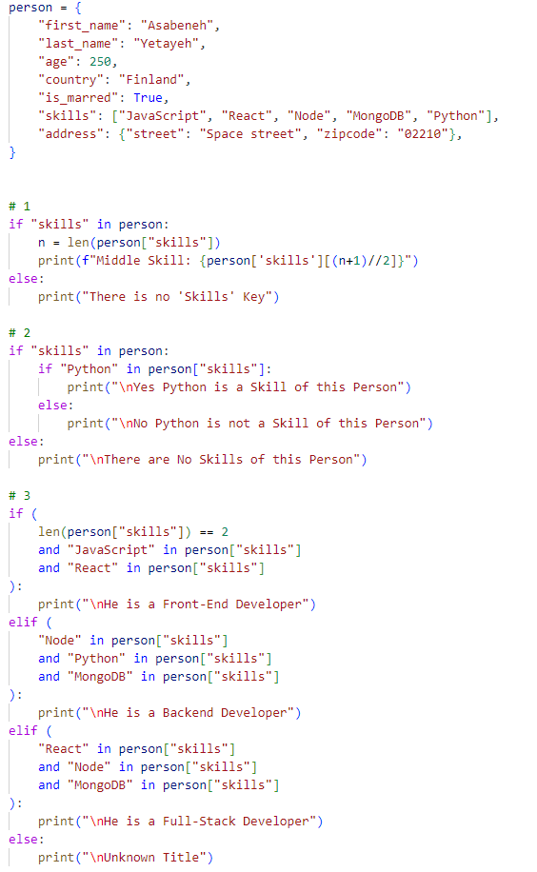 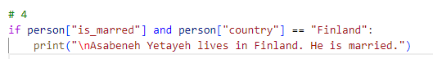

Output:

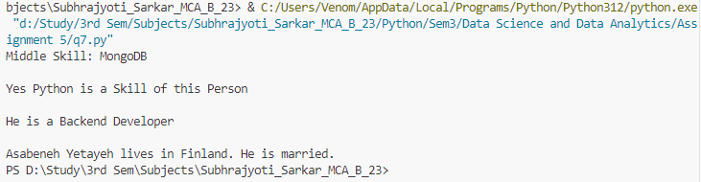

8. Print the season name of the year based on the month number using a dictionary.

Code:

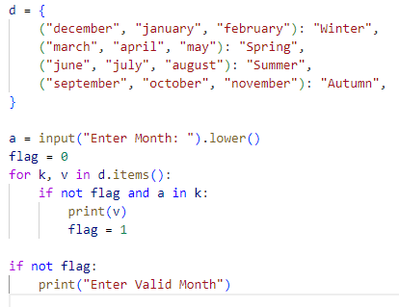

Output:

